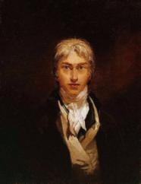
PART 1
Fill the gaps with the correct words.
He | working | Britain | face | history
People | seventeen seventy five | beautiful | paint box | eighteen fifty one
work | secret | greatest | famous | success

Joseph Melrod Willam Turner, born in _________________________ was unlikely a candidate to become Britain’s __________________ painter.
He was awkward, short-tempered and often difficult to deal with. __ have never lost his strong ____________ class accent.
____________ attending his lectures had little idea of what he was saying.
Turner travelled throughout __________ and Europe, often on foot carrying his _____________ . He sketched and painted lyrically _____________ landscapes that changed the _______ ___ of British art.
When he died in __________________ he was one of the wealthiest and ___________ artists in Britain’s _______ . Throughout his career he was always well aware of the key to his ___________ .
«The only __________ I have got is a damn hard _________».

Translate the last sentence.

PART 2.
- How old was William Turner when he began his career as a draftsman?

- Where did he study?

- What was the best (nobliest ) paintins according to Joshua Rainolds? (UNDERLINE: landscape, history, portrait, still life, genre).
- What was William’s Turner usual routine?

- Write the Russian translation to the words:
scene
mythology
hierarchy
portrait
Bible
genre
category
career
landscape
academy
romantic
association

- Match the genre with the painting:
Landscape, history, still life, portrait, genre, marine scene
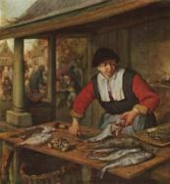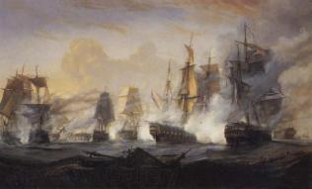
- ________________ 2. __________________ 3. ________________________________________

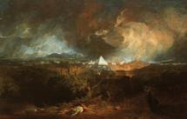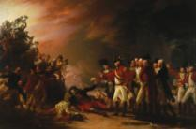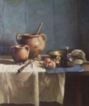
4. ____________________________ 5. __________________________ 6. _______________
PART 3.
- Who were the “teachers” for Turner’s at the beginning of his oil painting practice? Choose the right variants:
Arthur Dega, Nicolas Pusset, Clode Maunet, Tolouse Latrek, Pole Sezan, Clode Laurent, Ougust Roden, Gustav Klimt
- Match the words with their definitions:
SUBLIME | a picture that shows a natural scene of land or the countryside
SIGNIFICANCE | a person or way of behaving that is seen as a model that should be followed
LANDSCAPE | the quality of being important : the quality of having notable worth or influence
EXAMPLE | the myths of a particular group or culture
MYTHOLOGY | a picture that is painted : a picture made by putting paint on a canvas, board, etc.
PAINTING | to elevate or exalt especially in dignity or honor

PART 4
Which facts are connected with the following numbers:
eighteen fifteen
sixteen
twenty two
seventeen ninety three
eighteen oh five

PART 5
Correct the words
In 1819 he filnlya (_____________) reached atIly (_________) - the goal of artist throught uEreop (__________) eager to lear from its history and butaye (_________).
It was Turner’s long held dream to sivti(_________) the country he knew from Clode’s paintings. He depicted and idealized Italian ldcaanpes (________) and called it “Chilharold’s pilligrimage”.
In an attempt to lift the landscape ptianngi (__________) to the intellectual status enjoyed by the romantic poets, Turner included fntrmesag (___________) of Biron’s verse to the exhibition catalogue.

PART 6
BRING THE SENTENCES BACK TO ORDER
- Turner made it the staff of drama. Sequences of watercolours show he viewed the catastrophy from the variety of locations. Liquid splotches of red, grey and blue fight dramatically with each other.
- A series of water colors came out of the trip to Switzerland in 1841 which represent the supreme achievement in the medium that launched his career.
- Throghout the 1830 untill the 1840 Turner produced works with expressive brushwork. And this indistinctness buffled critics.
- Turner died in his home in Chelsey in December 1851.
- Turner continued to travel compulsively until the late of 1840 when his health no longer allowed it.
- The burning of the houses of Parliament” 1844 gave Turner one of his great subjects. The destruction of the national symbol of unity and the horror and agony that accompanied it was a staff for tabloids.

